OPEN_NEXT
Deliverable 3.3
Wikibase instance demonstrator - Semantic database for open linked knowledge on OSH products and services


This project is funded by the European Union’s Horizon 2020 Research and Innovation Programme under the Grand Agreement no. 869984.
OPEN_NEXT – Transforming collaborative product creation
Consortium:
# | Participant Legal Name | Short Name | Country
1 | TECHNISCHE UNIVERSITAT BERLIN | TUB | DE
2 | INSTITUT POLYTECHNIQUE DE GRENOBLE | GINP | FR
3 | ALEXANDER VON HUMBOLDT-INSTITUT FURINTERNET UND GESELLSCHAFT GGMBH | HIIG | DE
4 | UNIVERSITY OF BATH | UBA | UK
5 | ZENTRUM FUR SOZIALE INNOVATION GMBH | ZSI | AT
6 | FRAUNHOFER GESELLSCHAFT ZUR FOERDERUNG DER ANGEWANDTEN FORSCHUNG E.V. | FHG | DE
7 | DANSK DESIGN CENTER APS | DDC | DK
8 | WIKIMEDIA DEUTSCHLAND - GESELLSCHAFT ZUR FÖRDERUNG FREIEN WISSENS EV | WMDE | DE
9 | WIKIFACTORY EUROPE SL | WIF | ES
10 | STICHTING WAAG SOCIETY | WAAG | NL
11 | MAKER | MAK | DK
12 | AGILE HEAP EV | FLB | DE
13 | SONO MOTORS GMBH | SOM | DE
14 | OPNTEC GMBH | OPT | DE
15 | STYKKA APS | STY | DK
16 | TILL WOLFER | XYZC | DE
17 | FICTION FACTORY | FIF | NL
18 | M2M4ALL | SOD | NL
19 | INNOC OSTERREICHISCHE GESELLSCHAFT FUR INNOVATIVE COMPUTERWISSENSCHAFTEN | HAL | AT

Duration: 09/2019-08/2022
Grant: H2020-869984
Contact (coordinator): Prof Dr-Ing Roland JOCHEM
Address: Technische Universität Berlin, Sekretariat PTZ 3, Pascalstr. 8-9, 10587 Berlin
E-mail: roland.jochem@tu-berlin.de

Disclaimer: The contents of this document are not intended to replace consultation of any applicable legal sources or the necessary advice of a legal expert, where appropriate. All information in this document is provided "as is" and no guarantee or warranty is given that the information is fit for any particular purpose. The user, therefore, uses the information at his/her sole risk and liability. For the avoidance of all doubts, the European Commission has no liability in respect of this document, which is merely representing the views of the author(s).
D3.3 – „Wikibase instance demonstrator - Semantic database for open linked knowledge on OSH products and services“

Review and approval status:
 | Name and Surname | Role in the Project | Partner
Author(s) | Sonika Gogineni;  Martin Häuer | Work Package Lead;  Research Assistant | IPK
 | Elena Aleynikova;  Conny Kawohl | Work Package Development | WMDE
Reviewed by | Mehera Hassan | Research Associate | TUB
 | Pen-Yuan Hsing | Postdoctoral Researcher | UBA
Approved by | Robert MIES | Project Coordinator | TUB

History of changes:
Version | Date | Description of changes | By
0.1 | 01.10.2021 | Initial draft | Martin Häuer
0.2 | 08.10.2021 | Second draft version | Martin Häuer
0.3 | 15.10.2021 | Draft for review | Martin Häuer, Elena Aleynikova,  Conny Kawohl
1.0 | 26.10.2021 | Final document for final  project management  verification | Martin Häuer, Elena Aleynikova,  Conny Kawohl

Details:
Dissemination level | Open Access
Due date | 29.10.2021
Issue date | 29.10.2021
Contract No. | 869984
Responsible Partner | FHG
File name | D3.3_ Wikibase instance demonstrator.odt

Keywords:
Open source hardware, OSH metadata ontology, ICT for OSH, design reuse, open source development, distributed database, linked open data, collaborative production, documentation

Executive Summary:
This document aims at presenting the system of solutions developed around a distributed semantic database (using Wikibase as backend software) in order to facilitate design reuse in open source hardware (OSH) projects, which we named the “Library of Open Source Hardware” (LOSH). The system features a distributed knowledge base of a diverse set of OSH products. Based on automatic (crawler-based) data input, an intuitive frontend allows for the discovery of projects, distinct products and their explicit technical details. Additionally, an advanced query service enables the submission of more complex queries on the data set. Data is also provided in raw form following the Resource Description Framework (RDF) Model and Syntax Specification from W3C so that it can be integrated into other RDF frameworks or freely exploited as Linked Open Data.
The LOSH system is usable as a free-of-charge online service and as a freely exploitable, reusable system. For the latter, a modular development approach has been consequently followed and all components have been released under a free/open license.
As a free-of-charge online service, LOSH supports users to:
- find existing OSH solutions for design reuse or replication;
- identify relevant communities in a specific field of technology;
- scan the OSH market faster (e.g. to identify gaps and overlaps) in order to pilot newbusiness cases.
For SMEs this becomse particularly useful for ideation, to find inspiration in existent solutions, to reduce development efforts by design reuse and to get connected with relevant communities.
All data on LOSH is freely accessible through distinct channels (from the frontend, through an advanced query service or as Linked Open Data) and only refers to OSH documentation available under a free/open license, ensuring that those products are also freely exploitable, specifically for commercial use. This makes the hosted OSH metadata usable for a large variety of use cases, while trustable also for actors new in the field of OSH, as e.g. many SMEs.
Development was carried out in close and early collaboration with relevant open source communities, so that the LOSH system and its components can be maintained and developed further by them beyond the OPEN_NEXT project.
Requirements for the system were mainly based on user stories (from the former deliverable D3.1) and the preliminary findings of T2.3 (“Facilitating Documentation for design reuse”). In the requirements analysis it was found that “Community” and “Project Owner” are by far the most relevant target groups. Therefore, integration of the developed solutions into the existent open source ecosystem has been carefully considered. All solutions have been designed as modular, expandable and free/open as possible and in cooperation with communities from the open-source ecosystem to facilitate exploitation, remixing and long-term support beyond the OPEN_NEXT project.The development was carried out by Fraunhofer IPK and Wikimedia Deutschland e.V. By the deliverable of this report, the frontend is still under heavy development and could not be deployed for usage. However, this will be finished by the deliverable of D3.4 “Data collection” (February 2022).
A core element of the system is a specification for representative metadata for OSH (published here:) which, in the form of a computable data model, features the basis for the rest of the system. Requirements for the metadata specification are based on:
- preliminary findings of research carried out in the OPEN_NEXT project,
- relevant standards and specifications,
- specific needs derived from interviews with target groups,
- practical experience from relevant OSH communities.
The specification has been developed and published:
- in human-readable form here: https://github.com/OPEN-NEXT/OKH-LOSH/blob/master/OKH-LOSH.md
- as a computable data model here: https://github.com/OPEN-NEXT/OKH-LOSH/blob/master/OKH-LOSH.ttl
and can be implemented on any OSH online platform at a low threshold. As a starting point, it has been mapped onto data structures of several platforms so that data can be made available on the LOSH system without any change needed from those platforms.
Current state of software development: Open Source Ecology Germany e.V. (non-profit organisation representing a large part of the German OSH community) hosts LOSH as a free-of-charge online service for the duration of OPEN_NEXT (subcontrated) and for a minimum of three years (at own costs) after the OPEN_NEXT project.
Software modules developed in this deliverable:
- Wikibase instance
  - Knowledge base for semi-structured data, providing the backend for LOSH;
  - setup and configuration finished; service is publicly available under https://losh.ose-germany.de/; its advanced query service is publicly available under https://losh.ose-germany.de/qs/;
- LOSH-Frontend
  - Frontend App allowing the exploration of data from the Wikibase instance
  - under development, partly in testing stage; public contribution is possible via the official repository: https://github.com/wmde/LOSH-Frontend/

- RDF2WB
  - Tool for the initial upload of an RDF ontology (e.g. OKH-LOSH) when setting up a LOSH system;
  - development is finished; the tools has been successfully tested and is publicly available for download under https://github.com/OPEN-NEXT/OKH-LOSH-Ontology-RDF2WB .
The development was carried out by Fraunhofer IPK and Wikimedia Deutschland e.V. By the deliverable of this report, the frontend is still under heavy development and could not be deployed for usage. However, this will be finished by the deliverable of D3.4 “Data collection” (February 2022).

Table of Contents
>_1 Introduction 1
1.1 Problem Statement 2
1.2 Requirements Analysis 2
1.2.1 General 2
1.2.2 Requirements for the LOSH System 4
1.2.3 Requirements for the OKH-LOSH Specification 5
>_2 The LOSH System 6
2.1 Overview 7
2.2 Dataflow 11
2.3 Current State 11
2.4 Practical Use 12
2.4.1 Uploading Metadata 12
2.4.2 Discovering OSH 19
>_3 The LOSH Modules 25
3.1 OKH-LOSH 26
3.1.1 Description 26
3.1.2 Usage 27
3.1.3 Summary and Outlook 28
3.2 RDF2WB-Converter 29
3.2.1 Description 29
3.2.2 Usage 30
3.2.3 Summary and Outlook 30
3.3 LOSH-Frontend 31
3.3.1 Description 31
3.3.2 Usage 31
3.3.3 Summary and Outlook 32
>_4 Cooperations with Open Source Communities 33
>_5 Summary and Outlook 38
>_6 Glossary 42
6.1 Application Programming Interface 43
6.2 Fab lab 43
6.3 Linked Open Data 43
6.4 Open Source Hardware 43
6.5 OSH Module 43
6.6 SPARQL 44
>_7 Licenses & Attributions 45
>_8 References 48

List of abbreviations and terms
API | Application Programming Interface
DOI | Digital Object Identifier
FOSS | Free/Open Source Software
LOD | Linked Open Data
LOSH | Library for Open Source Hardware
OKH | Open Know-How
OKHv1 | Open Know-How Manifest Specification Version 1.0
OSH | Open Source Hardware
PCB | Printed Circuit Board
QR | Quick Response (used in the context of a matrix barcode (QR code))
RDF | Resource Description Framework
RDF2WB | Resource Description Framework to Wikibase
SME | Small and Medium-Sized Enterprises
SPARQL | Simple Protocol and RDF Query Language

Table of Figures
Figure 1: Connection with target groups in tasks of this work package (WP3) 3
Figure 2: Data flow principle of LOSH 10
Figure 3: Data upload via an integrated online platform 13
Figure 4: Screenshot of the "Sion PowerPlanter" project on the Wikifactory platform 14
Figure 5: Screenshot of the imported "Sion PowerPlanter" project on the LOSH frontend 15
Figure 6: Data upload via the use of a manifest file 16
Figure 7: Screenshot of the "OHLOOM" project on the GitLab platform 17
Figure 8: Screenshot of the imported "OHLOOM" project on the LOSH frontend 18
Figure 9: Direct data upload using the Wikibase API 19
Figure 10: Screenshot of the web interface of LOSH's advanced query service 23
Figure 11: Interactions with and between OSH communities for this deliverable 35

Index of Tables
Table 1: Overview of the modules forming the LOSH system 7

Introduction

Problem Statement
Open source hardware (OSH) products are (usually) developed in a collaborative process in dedicated communities using online platforms. However, in practice a variety of different online platforms is used and products are published in very distinct qualities, sometimes with incomplete documentation [1] or under licensing terms that prohibit commercial exploitation or the publication of derivatives [2] (which is, by definition, not open source [3], [4]). This has been reflected in the research carried out in the OPEN_NEXT project [5] and previous research projects like OPEN!. In consequence, potential users who are not yet skilled in the field of OSH (e.g. regarding available platforms or free/open licensing) are confronted with a relatively high threshold to find, use and exploit those solutions. As a result, efficient design reuse and decentral replication of OSH solutions is hindered by a) the lack of a central entry point to discover OSH from different sources and b) a necessary double-check (e.g. regarding licensing terms) to ensure usability once promising designs have been found.
Despite that, the diversity of online platforms offers users a wide range of specialised features for their needs and grants them the right to license and publish their hardware designs however they prefer. The aim of solutions developed in this deliverable is not to supersede this by a centralised system competing with other online platforms, but to bridge the gaps between them.
The system of solutions developed in this deliverable is named the Library of Open Source Hardware (LOSH). The specification OKH-LOSH defines representative metadata for OSH, which in turn feed the distributed database of LOSH. Thereby, OSH designs become searchable across different online platforms and are available as Linked Open Data (LOD), while OSH developers can still freely choose their favourite online platform for publishing and development.

Requirements Analysis

General
The main target groups of solutions addressing this issue are “community” and “project owners”. this was found in the analysis of interviews carried out with target groups for ICT solutions of the OPEN_NEXT project. That target groups include OSH developers as well as fab labs and SMEs, on both the provider and user side.
The metadata specification OKH-LOSH constitutes a central component of it since it sets requirements for the rest of the system. Consequently, requirements have been gathered, analysed and translated into specific design criteria and features for both, the system LOSH and the specification OKH-LOSH. The main sources for requirements have been the preliminary findings of research carried out in the OPEN_NEXT project and interviews with representatives from the target groups of ICT solutions in this work package (WP3). While research set high-level criteria for LOSH, the interviews led to 80 specific needs in the form of user stories. These were sorted into needs that would be a) directly, b) indirectly or c) not addressable by LOSH. Of all user stories, 19 % have been found to be directly addressable by solutions, 22 % indirectly (meaning supported by solutions, but not fully covered), and 59 % were deemed out of scope. In this, “Community” and “Project Owner” sum up to 81 % of the overall perspective on addressable user stories.
The gathered requirements also affect other tasks in this work package (WP3), in particular solutions targeted for “Data collection” (T3.4) as the Krawler and the “Validation of demonstrators” (T3.5). For the latter, usefulness of developed solutions shall be checked against expectations from target groups that once formulated their needs in interviews conducted for the prior deliverable “User stories of collaborative engineering needs“ (D3.1). This connection is illustrated in Figure 1.
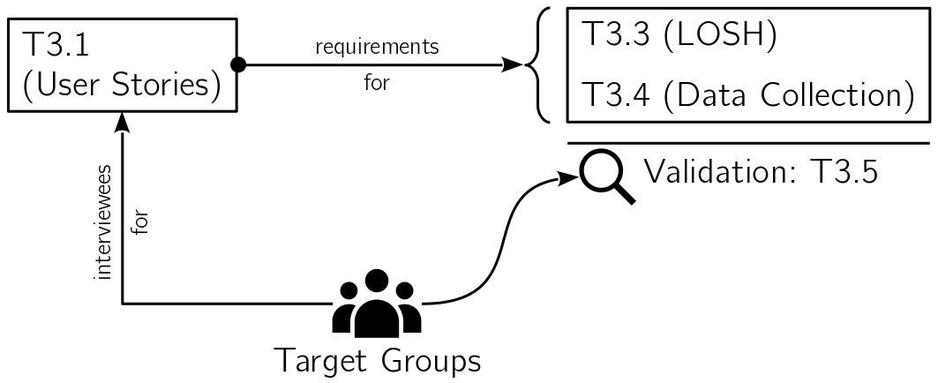Figure 1: Connection with target groups in tasks of this work package (WP3)
The following sections in this chapter aim to provide an intuitive summary of conclusions from the requirements analysis; for in-depth information, including further sources for requirements that have been considered, please see the requirements analysis in ch. xxx of the annexure.

Requirements for the LOSH System

Exploitability through Open Source
To scale exploitability of LOSH, all developed software modules shall be published under a free/open license alongside with meaningful code documentation. Furthermore, LOSH shall be designed to be usable in two different forms: as a free-of-charge online service and as a reusable system by copying and optionally remixing modules to apply the system to new use cases.
Furthermore, the team aimed for an integration into the existing open source ecosystem in order to provide long-term support and wide adoption of developed solutions beyond the OPEN_NEXT project. For this, several cooperations with relevant open source communities have been established, for details see ch. 4.

Modular System Design
Especially for complex projects, modularity is a key best practice for free/open source software (FOSS) [6]. Applied to LOSH, this would i.a. improve the exploitability, maintainability and flexibility of the system. LOSH would be applicable for a large variety of use cases in the domain of LOD, beyond OSH, while modules can be remixed, substituted and added. For examples see ch. xxx in the annexure.

Multi-Source Data Input
Data input is possible from a variety of online platforms, so that “the Wikibase instance covers a large part of the OSH already published online”, as stated in the description of T3.4 “Data collection”. It was expected that every online platform uses its own data structure and fields; additionally, in very distinct qualities – this could be confirmed by the experience gained in during the development in this task.
Hence, LOSH is confronted with data in diverse structures, incomplete or outdated data and products falsely claiming to be open source. To keep data discoverable and useful, data input shall be possible via selected Application Programming Interfaces (API), while an automated quality check prior to the submission to the knowledge base should ensure a certain minimum quality (e.g. that data and referenced OSH are available under a free/open license). A test crawl on the Wikifactory platform demonstrated that only 11,7 % of all hardware projects hosted on the platform come with a free/open license – which illustrates the practical relevance of that prior quality check.

Data Exploitability
To offer the full potential of the knowledge base, data shall be available via three distinct channels:
- an easy-to-use frontend,
- the Wikibase query service,
- in its raw format (RDF).
While target groups will most likely refer to the frontend to discover the knowledge base, the other two channels enable several additional use cases such as querying more complex questions beyond the functionality of the frontend and restrictionless linking and integration into other knowledge bases. Aside from the target groups this can be particularly useful for data service providers, OSH online platforms and for further research purposes since LOSH would feature the biggest knowledge base of its kind.

Requirements for the OKH-LOSH Specification
Since the approach of standardised metadata for OSH is currently being piloted by the Open Know-How community [7], the OKH-LOSH specification shall a) make use of the work carried out and the practical experience gained by the project and b) contribute back to the OKH project.
The specification aims for easy adoption by OSH developers and OSH online platforms and a lean design avoiding data fields that do not directly contribute to its scope. It is available in both human- and machine-readable form, the latter constituting the computable data model (ontology) needed to structure the date in the knowledge base. For better maintainability and compatibility to other knowledge bases, existing ontologies and knowledge bases shall be linked as far as possible. Metadata fields are primarily derived from high-level requirements found by the research carried out and specific needs addressed the interviews with relevant target groups.

The LOSH System

Overview
Scope: Support design reuse and decentral replication of OSH modules by improving their discoverability.
The system featuring LOSH is made of the solution modules listed below in Table 1. Please note that some of the listed modules are still in development and due for the next deliverable, hence don’t carry a digital object identifier (DOI) yet. In consequence, LOSH is currently only usable with limited features.
Table 1: Overview of the modules forming the LOSH system
Name | Purpose | Repository | DOI
OKH-LOSH | Ontology for LOSH and specification for data input & format | https://github.com/OPEN-NEXT/OKH-LOSH/ | 10.5281/zenodo.5608513
Wikibase | Knowledge base for semi-structured data, providing the backend for LOSH | https://github.com/wikimedia/Wikibase | not available
RDF2WB-Converter | Tool for the initial upload of an RDF ontology (e.g. OKH-LOSH) when setting up a LOSH system (see ch. 3.2 for details) | https://github.com/OPEN-NEXT/OKH-LOSH-Ontology-RDF2WB/ | 10.5281/zenodo.5535759
Krawler | Tool for automatic data upload to LOSH from multiple sources | https://github.com/OPEN-NEXT/LOSH-krawler/ | scheduled for D3.4
WikibaseReconcileEdit | Reconciliation API to consolidate, deduplicate and allow for batch input of OSH data into the Wikibase instance. | https://github.com/OPEN-NEXT/WikibaseReconcileEdit | scheduled for D3.4
OSH-Repository-Checker | Command-line tool for quality checks of OSH repositories, either manually or as automated job | https://gitlab.com/OSEGermany/osh-tool/ | scheduled for D3.4
OKH-LOSH Manifest File Creator | An online assistant and graphical interface for the creation of manifest files | scheduled for D3.4 | scheduled for D3.4
LOSH Appropedia Scraper | Tool to make OSH projects on Appropedia searchable for the Krawler | https://github.com/OPEN-NEXT/LOSH-Appropedia-Scraper | scheduled for D3.4
LOSH Frontend | Frontend App allowing the exploration of data from the Wikibase instance | https://github.com/wmde/LOSH-Frontend/ | scheduled for D3.4
LOSH Reporter | Communication tool to create periodic, automatic PDF reports with statistics based on latest LOSH data | scheduled for D3.4 | scheduled for D3.4

These solutions constituting the LOSH have been designed to be usable in two different forms:
- LOSH as a free-of-charge online service, with
  - a frontend as primary entry point for the target groups, accessible via losh.opennext.eu;
  - a query service as option of choice for users with more complex question to the knowledge base, available via losh.ose-germany.de/qs
  - a RDF export per executed data input on LOSH for users with the need of restrictionless exploitation of the data (as researchers and platform owners).
- LOSH as a reusable software system,
  - as a whole, applied to similar use cases beyond OSH or
  - as partial solution either embedded in a bigger framework with more modules or using and remixing individual modules of the system.
Within the scope of this deliverable, the targeted users are expected to use LOSH as a free-of-charge online service only (see ch. 2.4 for details). However, to enable further exploitation beyond the OPEN_NEXT project, reusability of the system or individual software modules has been considered in the design and development of those modules.
The following flowchart, Figure 2, illustrates the connection between most essential modules for LOSH as a running, free service. The arrows demonstrate the data flow.
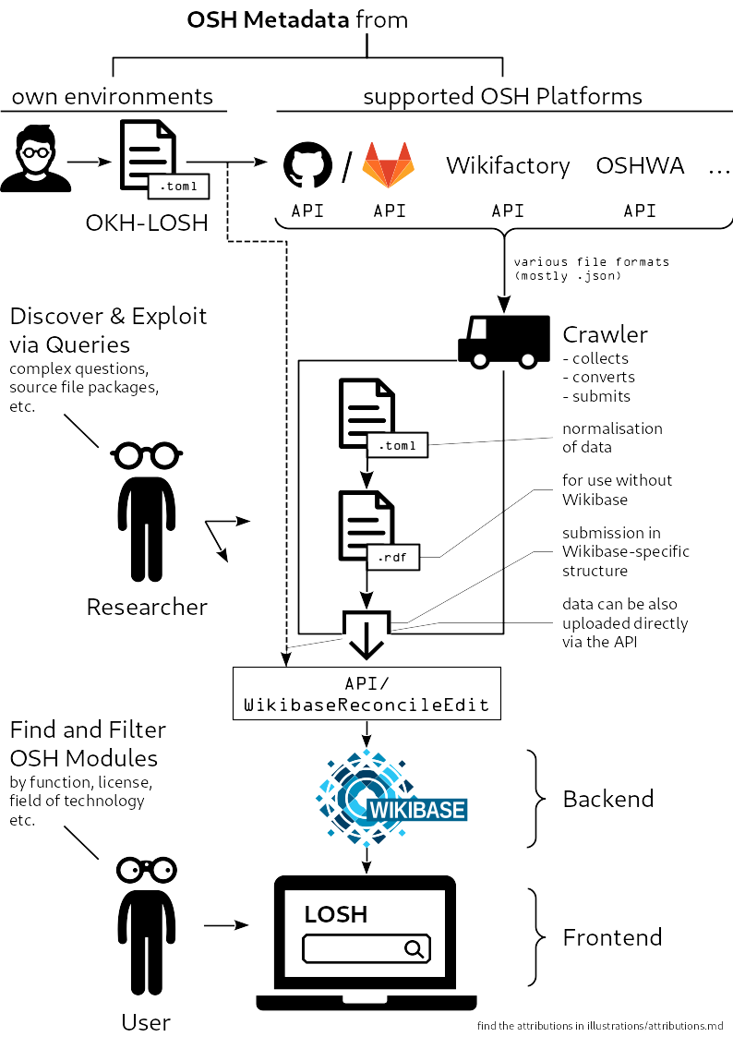Figure 2: Data flow principle of LOSH

Dataflow
The LOSH system features a distributed database with automatic data processing and several output channels. Data is collected by the Krawler from selected, publicly available APIs from online platforms (e.g. GitHub or Wikifactory).
Data can either be available directly via the API (as in the case of Wikifactory) or via plain text files containing structured metadata (“manifest files”, as in the case of GitHub).For the latter, OSH developers can upload a manifest file complying with the OKH-LOSH specification to a publicly available repository (e.g. on GitHub) and the Krawler will consecutively identify them. Collected data is normalised and converted into RDF by the Krawler, subsequently converted into a Wikibase-specific data format and submitted to the Wikibase API as a deduplicated batch upload. From there, the data is publicly accessible via the built-in Wikibase API (using the Query Service), or for the LOSH frontend which allows for the LOSH data to be explored in an easy-to-use interface. The RDF data is published separately under a free/open license on a public GitLab repository and thus available as LOD (see ch. 2.4.2 for details).

Current State
Open Source Ecology Germany e.V. will host LOSH as a free service for a minimum of three years at their own costs after the OPEN_NEXT project, since LOSH directly contributes to their goal to improve discoverability and standardisation among OSH products. The organisation has been subcontracted to host the LOSH system already during OPEN_NEXT so that defects possibly occurring during testing can be resolved jointly. This should prepare a smooth handover by the end of OPEN_NEXT and also lapses the otherwise necessary extra effort of moving from TU Berlin to OSEGeV servers.
Since work on the following task T3.4 “Data collection” is ongoing, the knowledge base currently contains real world data both manually curated by the team and collected from a first test crawl of GitHub and Wikifactory. As a result, that data is already discoverable on the Frontend, the Wikibase query service and the raw RDF.
State of related software modules released in this deliverable:
- Wikibase instance
  - has been set up, configured and tested and is publicly available under https://losh.ose-germany.de/;
  - its advanced query service has been set up and configured and is publicly available under https://losh.ose-germany.de/qs/;
- LOSH-Frontend
  - under development, partly in testing stage; public contribution is possible via the official repository: https://github.com/wmde/LOSH-Frontend/
- RDF2WB
  - has been published and successfully used to set up LOSH; the tool is publicly available as stable release on GitHub under https://github.com/OPEN-NEXT/OKH-LOSH-Ontology-RDF2WB .

Practical Use

Uploading Metadata

General
LOSH offers the upload of OSH metadata through three distinct channels: automatically via mapped platform APIs, semi-automatically via generic platform APIs and manifest files and manually via the Wikibase API. The vision of LOSH is to have as many mapped platform APIs as possible so that data upload is fully automated, erasing any additional work for users. By the current state, full compliance with the OKH-LOSH specification is yet only possible through the use of manifest files (semi-automatic upload) or the Wikibase API (manual upload). Hereby the use of manifest files may be the preferred option to upload individual modules, since no knowledge about the OKH ontology is needed. However, that way presupposes the use of a platform supported by the Krawler. For larger data sets, e.g. platform owners that want to connect to LOSH, upload via the Wikibase API may be a more suitable option. That way, the uploader holds control of the data mapping as well as frequency and extent of uploads. All three options are already available and partly in use. For instance, all pilots in OPEN_NEXT that use the Wikifactory platform for development are already searchable platform-independent on LOSH.

Per Integrated Online Platforms
When OSH developers choose to upload the technical documentation of an OSH module to an online platform that is fully integrated into LOSH (such as Wikifactory), metadata is available directly by the API of that platform. No extra step is required from OSH developers – by the next crawl the metadata will be uploaded to the Wikibase instance automatically. Figure 3 illustrates this in schematic form (dashed lines mark data flows independent from user interaction).
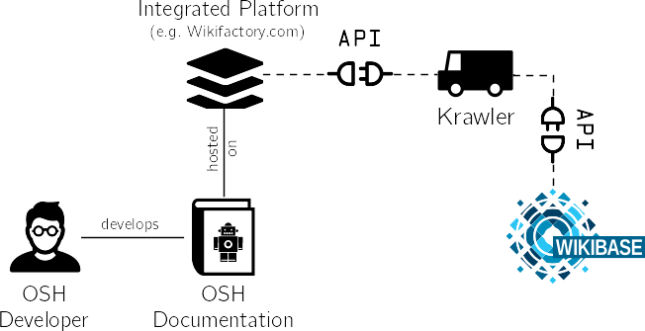Figure 3: Data upload via an integrated online platform
Versioning of that OSH module and the related metadata is fully performed by the online platform.
Example Case: Sion PowerPlanter
“Sion PowerPlanter” is an OSH project released on Wikifactory by OPEN_NEXT project partner Sono Motors (see Figure 4). The Krawler gets the relevant metadata directly from the API of the Wikifactory platform and uploads it to the Wikibase instance, from where it becomes available for the frontend (see Figure 5).
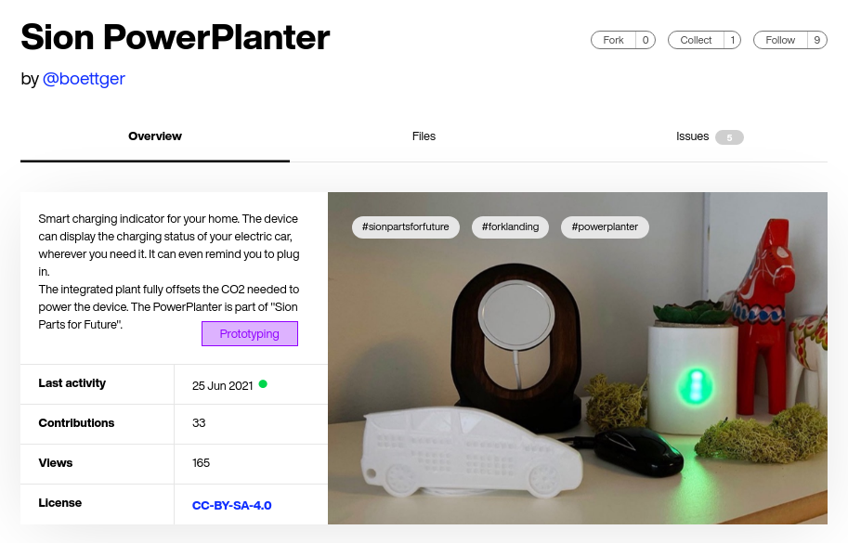Figure 4: Screenshot of the "Sion PowerPlanter" project on the Wikifactory platform

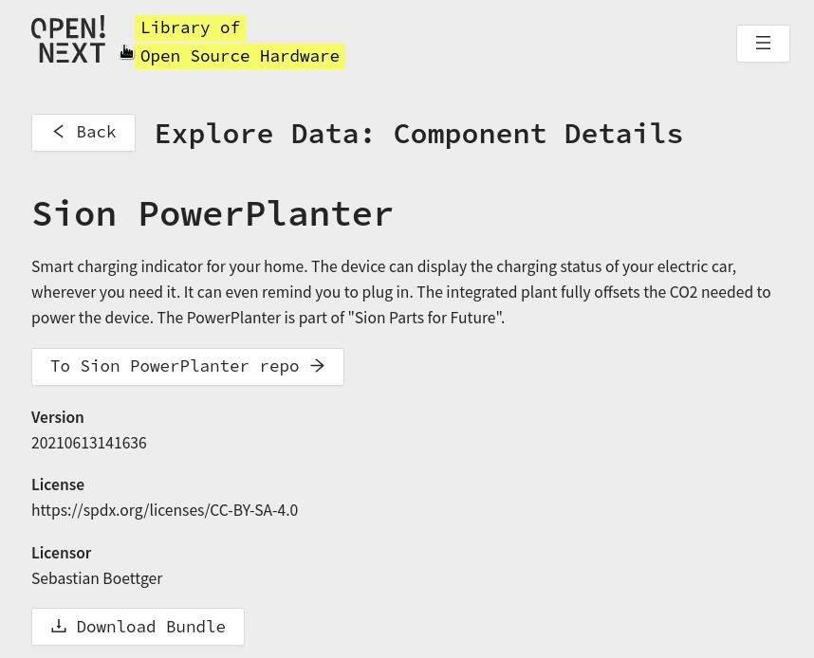Figure 5: Screenshot of the imported "Sion PowerPlanter" project on the LOSH frontend

Per Manifest File
Alternatively, OSH developers may only upload a manifest file, containing relevant metadata, to an online platform supported by LOSH (e.g. GitHub.com), while the actual technical documentation can be hosted on any other platform. The manifest file is searchable for the Krawler through the API of the supported online platform. By the next crawl metadata, that manifest file will be found and processed; data will be uploaded to the Wikibase instance automatically. Figure 6 illustrates this in schematic form (dashed lines mark data flows independent from user interaction).
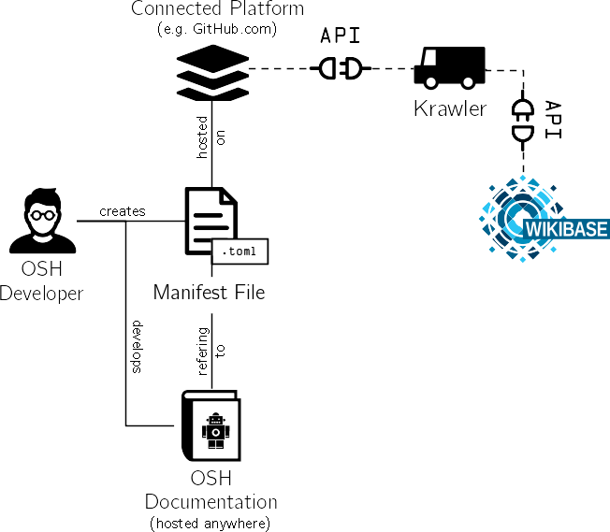Figure 6: Data upload via the use of a manifest file
Versioning is done through the “version” field in the manifest file: When the version field is updated, the Krawler processes the manifest file for a new version of the OSH module.
Example Case: OHLOOM
The OHLOOM project is released on GitLab (see Figure 7), while a manifest file is available on GitHub. The Krawler finds the manifest file using the GitHub API, uploads it to the Wikibase instance, from where it becomes available for the frontend (see Figure 8).
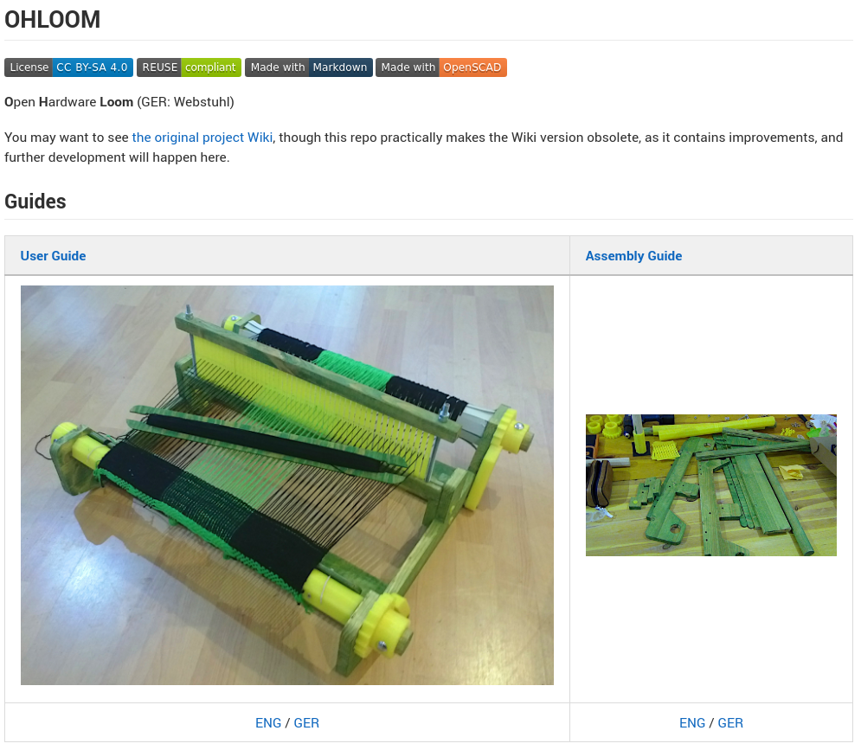Figure 7: Screenshot of the "OHLOOM" project on the GitLab platform
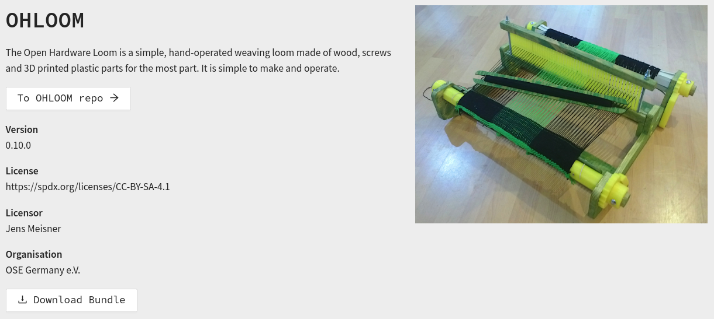Figure 8: Screenshot of the imported "OHLOOM" project on the LOSH frontend

Directly Via the Wikibase API
Via its API, Wikibase supports a direct upload of metadata. The module WikibaseReconcileEdit allows for OSH metadata to be uploaded in bulk (also for multiple projects), while also deduplicating, normalizing and cleaning up the presented data. The data submitted needs to follow the OKH-LOSH ontology and must be in RDF (or JSON-LD). Figure 9 illustrates this in schematic form.
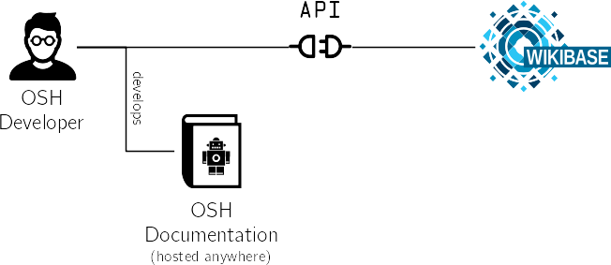Figure 9: Direct data upload using the Wikibase API
As outlined above, this is a manual process and not geared towards an end user unskilled in the use of APIs. Versioning is fully performed by the uploading party. Access to the Wikibase API can be obtained through OSEGeV.

Discovering OSH

General
Users, such as fab labs and SMEs can use LOSH as a free online service to:
- find existing OSH solutions for design reuse or replication;
- identify relevant communities in a specific field of technology;
- scan the OSH market faster (e.g. to identify gaps and overlaps) in order to pilot new business cases.
For SMEs, this becomes particularly useful in the development phase of ideation to explore what has been done already, how and by whom. This helps to:
- find a feasible design for a specific problem, while considering practical limits visible in existent, similar solutions;
- reduce development efforts by (possibly) directly copying (parts of) existent solutions for the desired use case;
- get connected with the communities behind relevant solutions in order to collaborate on joint efforts.
Alternatively, users could come to a similar result by scanning OSH online platforms individually for solutions. However, doing so would require the following:
- Users would need to know a) which OSH online platforms exist, b) which of those can be valuable for a technology research, as platforms can have a narrow focus (e.g. towards a certain technology, manufacturing method, use case or documentation maturity) and c) how to navigate through them.
- Generic platforms like GitHub, GitLab or Appropedia don’t offer the functionality to search specifically for OSH. Users would need to apply (and possibly first develop) suitable searching methods.
- Most platforms do not require publishing hardware designs under a free/open license. This means that users must be knowledgeable in licensing schemes to assess whether or not they would be allowed to (e.g. commercially) exploit a hardware design.
LOSH makes OSH data from different platforms directly explorable, trustworthy (regarding free exploitation rights) and jointly filterable after selected criteria, even though data is structured differently on each original platform.
Data from the LOSH knowledge base is explorable:
- on the frontend,
- via an advanced query service directly on the Wikibase instance,
- as raw RDF.
The frontend may be the main entry point for users to explore and filter data. User experience design has been kept clear and intuitive, features aim to be easy-to-use and -understand. Users are not expected to regularly spend a large amount of time on LOSH, but rather use it as a quickly available online tool, such as an online dictionary. As an example to illustrate the practical relevance of this: The “Ventilator Verification Project” from the PubInv community assessed OSH ventilator designs to evaluate their usability for Coronavirus disease 2019 crisis response. The project found 144 designs while just 6 made it to actual clinical adoption [8]. The project aims to connect developing communities to foster design reuse principles, which may lead to fewer, but more mature designs. LOSH makes such technology searches possible at a very low effort, potentially helping to prevent such cases in the future.
The advanced query service on the Wikibase instance allows users experienced with the “Simple Protocol and RDF Query Language” (SPARQL) and knowledgeable about the OKH-LOSH ontology to a) send more complex query requests to the platform and b) get results in a compact machine-readable export format for further data processing. This can be specifically useful for researchers e.g. to get in-depth statistical data on OSH or OSH organisations and think tanks when assessing the current state of OSH.
The Raw RDF version of LOSH data allows for a) implementation of that data into other RDF frameworks (which removes the dependency on Wikibase for the LOSH system) and b) free linking of LOSH data as LOD. The latter unleashes the full potential of the data as it becomes usable for any other knowledge base online. For instance the British Broadcasting Corporation or national libraries use LOD to cross-link information in order to improve their search engine results [9]. Apart from that, new information can arise from the cross-linking of information and it also contribute to a reflux of critical information.

On the Frontend
Using the LOSH Frontend, users are able to easily explore the knowledge base. Upon entering the page, the user will be greeted with a large datatable representing the LOSH datasets stored within. Users can then interact with the page e.g. by searching for a specific technology of interest, or filtering for specific data points. Clicking on one of the rows that represent a single item, one is led to a detail page showing further details on the dataset and its related potential actions. For details and screenshots please see the related design notes in ch. xxx of the annexure.

Using the Advanced Query Service
Using Wikibase’s query service, distinct questions can be formulated in SPARQL to query for specific aspects of the data set. A question that a SPARQL query might help answer could be: “How are OSH modules on LOSH distributed among supported online platforms?”.
Such requests can be sent either to
- the web interface of Wikibase’s query service (suited for human interaction),
- the Wikibase API (suited for interaction between software modules).
The web interface of LOSH’s advanced query service can be accessed under https://losh.ose-germany.de/qs/, where SPARQL queries can be entered – see Figure 10 for a screenshot.
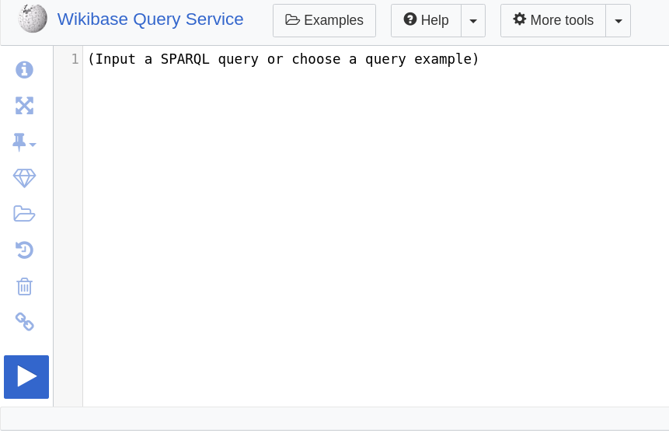Figure 10: Screenshot of the web interface of LOSH's advanced query service
As an example, for querying all OSH modules on the LOSH, users could enter the following SPARQL query:
#All properties with descriptions and aliases and types
SELECT ?property ?propertyType ?propertyLabel ?propertyDescription ?propertyAltLabel WHERE {
?property wikibase:propertyType ?propertyType .
SERVICE wikibase:label { bd:serviceParam wikibase:language "[AUTO_LANGUAGE],en". }
}
ORDER BY ASC(xsd:integer(STRAFTER(STR(?property), 'P')))
Results can be downloaded in various formats, including JSON, CSV or as an HTML table.
The same request could be alternatively sent to the Wikibase API, available at https://losh.ose-germany.de/w/api.php . This allows for direct queries from other software modules. The query mentioned above would then be submitted through the following link:
https://losh.ose-germany.de/w/api.php?action=query&list=allpages&apnamespace=122&aplimit=max&format=json&origin=*
leading to an equal result in JSON format.

From Raw RDF
LOSH data as raw RDF is available under a permissive free/open license in a dedicated GitLab repository running on OSEGeV servers. After each crawl performed by OSEGeV, RDF data is uploaded and versioned accordingly using git tags. Consequently, this GitLab repository constitutes a publicly available, consistently versioned mirror of the data hosted on LOSH. Information can be referenced directly using the RDF URLs.
For instance
https://gitlab.opensourceecology.de/verein/projekte/losh-rdf/-/raw/v0.1/RDF/appropedia.org/Backpack_frame_bike_trailer/0_0/okh.ttl#Backpackframebiketrailer
directly refers to the crawled information about the Appropedia project “Backpack frame bike trailer” in RDF form. Values from properties would be then available for queries. This however, as well as further data processing, requires an installed RDF framework on the user side; this functionality was not tested within this deliverable.

The LOSH Modules
(released in this deliverable)

OKH-LOSH

Description

Scope
OKH-LOSH is the specification inside LOSH for representative metadata of OSH modules. As such it is also the underlying ontology for LOSH. Its main goal is to improve the discoverability of OSH and design reuse. For this purpose, wide acceptance among a) OSH developers and b) online platforms is a crucial factor. Therefore, the specification aims for:
- a lean and modular design in compact, comprehensive language, yet specific enough for specifications and standards;
- high portability among different OSH online platforms;
- a high level of integration into the open source ecosystem;
- easy extensibility to more use cases.
The result is available as human-readable specification document and as machine-readable ontology. The main target group of the human-readable specification were OSH developers, specifically from fab labs and SMEs, supposingly with no prior knowledge about LOD in general or LOSH in particular. One the other hand, the main target group of the ontology were platform owners willing to integrate the metadata specification, either to gain a higher visibility of their data (since their hosted products get listed on LOSH) or to improve their own data structure by reusing parts of the OKH-LOSH logic.
As outlined in ch. 1.2.3, the requirements for the design have been mainly derived from the preliminary findings of research carried out in the OPEN_NEXT project, the open source standard DIN SPEC 3105-1, needs mentioned in interviews with representatives from the target groups and the Open KnowHow Specification for OSH metadata. For details on the requirements analysis and derived conclusions for the design of the specification, please refer to ch. xxx of the annexure.

Main Features
The specification primarily consists of two parts:
- general requirements, explaining basic concepts of LOSH and the specification, supported platforms and the use of manifest files;
- metadata fields, classified in mandatory and recommended information, whereby production-related metadata has been listed separately under recommended information.
The OKH-LOSH specification links to additional documents defining the mapping of data between supported platforms and the OKH-LOSH ontology. This includes a mapping to the OKH specification. This ensures downward compatibility to OKH so that all projects compliant to the OKH specification will be integrated into LOSH as well.
The human-readable specification document is currently not automatically processed into a machine-readable ontology. As to facilitate quality checks regarding the consistency between both documents, the team set up an automatic graph rendering of the ontology, executed after every change done to it.

Usage
Recipients of the specification are not expected to read through it as a whole. Sections are extensively cross-referenced so that the document serves primarily as a reference to answer specific questions arising during practical adoption; e.g. how certain data fields and their input format are defined. For instance, for uploading a project using a manifest file, basic information will be available on the frontend as well as the OKH-LOSH Manifest File Creator. In contrast, when a fully integrated platform like Wikifactory is used to upload an OSH project, no interaction with the specification is required, as the Krawler gets data from the corresponding API. For details on how to upload a project to LOSH, please refer to ch. 2.4.1.
Recipients of the ontology can choose to a) copy or fork it or b) reference to (specific parts of) it, while the latter, as a classic LOD use case, will be the most common application. The ontology is consistently versioned and fully version controlled using a GitHub repository. Releases are accessible under https://github.com/OPEN-NEXT/OKH-LOSH/releases .
By the usage of git tags, a stable URL is available for each version of the ontology. To create a linking, recipients:
- shall choose a specific release first to ensure that the linking will be stable;
- select the ontology document (“OKH-LOSH.ttl”) of that release;
- view the “raw” version of the document;
- copy the URL and append the identifier of the property, class or instance to it.
For instance,
https://raw.githubusercontent.com/OPEN-NEXT/OKH-LOSH/v1.0.0/OKH-LOSH.ttl#repository
references the property “repository” in version 1.0.0 of the ontology.

Summary and Outlook
The OKH-LOSH features the first specification to make representative metadata of OSH modules available as LOD. The current version 1.0.0 aims to provide a robust approach for the pilot phase of LOSH within the OPEN_NEXT project. Since all relevant documents (including linked ontologies) are free/open source, modifications and extensions can be either suggested per issues on GitHub or made directly by forking. The team has been in close exchange with OKH working groups and will shortly present OKH-LOSH to maintainers and leaders of the programme to discuss possible endorsement and next steps. For more details see ch. 4.

RDF2WB-Converter

Description

Scope
The RDF2WB-Converter is a command-line tool to upload a RDF-based ontology (such as OKH-LOSH) to Wikibase. Since Wikibase uses its own RDF implementation this step requires conversion. Consequently, the Wikibase instance within LOSH will not function without the correct ontology, this is a crucial functionality. RDF2WB is currently configured for LOSH, so it can be directly used by administrators to update possible changes of the ontology on Wikibase. LOSH administrators are the main target group for this development. However, its generic approach makes it potentially applicable to any ontology structure yet supported by Wikibase, although this has not been tested within this deliverable.

Main features
For the target group, the tool was kept “bare-metal”: it creates Wikibase properties and objects on the desired server and provides status logs, but nothing else. Following this GNU/Linux best practice, the tool can easily be integrated into other tool chains, including GitLab’s CI to automate the execution of the tool.

Usage
As the tool is currently configured for the use case of LOSH, it will automatically connect to the current OKH-LOSH ontology and upload it to the Wikibase instance of LOSH. How the envisioned target group is meant to use the tool quasi equivalent ontology on the target Wikibase instance (which is also preconfigured) through its API. This action requires editing rights for the Wikibase instance, which should be given for administrators maintaining the platform. This process is triggered by executing a single command line:
python3 rdfont2wb.py 'USERNAME' 'PASSWORD'
whereby USERNAME and PASSWORD are to be replaced by the corresponding credentials. The tool will output a detailed log of all properties and objects created on the target Wikibase instance, including a non-zero exit status for easier troubleshooting in case of errors.

Summary and Outlook
The RDF2WB-Converter forms a crucial part of the LOSH tool chain. For this deliverable, the tool has been tested and successfully used, hence the current release can be deemed stable. As applicable for other use cases it also fills an important gap in other tool chains, since with RDF2WB ontologies for Wikibase will no longer need to be created and maintained on Wikibase alone. This may lower the threshold of using Wikibase for a specific use case and reduce its lock-in effect as exports of an ontology from Wikibase are not processible in other RDF frameworks. In contrast, developing and maintaining an ontology in RDF keeps the ontology compatible among most RDF frameworks, while RDF2WB makes it usable within a Wikibase environment. This may facilitate the acquisition of new contributors as well as broader adoption of affected ontologies (including OKH-LOSH).

LOSH-Frontend

Description
The LOSH Frontend aims to allow users easy exploration of the OSH data stored in the LOSH wikibase instance without prior knowledge. It is a powerful tool with which to search and filter through the entire dataset while providing background information on the project and its ecosystem.

Scope
Common options for exploring the data stored in the LOSH are technical and require specific domain knowledge. While powerful, these may not allow for graphical, web browser-based interaction with the data.
Using the React library with TypeScript, the Gatsby static site generator and NPMt, provide a modern frontend that supports interested parties to explore OSH data in a user-friendly manner.

Main features
- Data explorer - a datatable on the home page that displays the de-facto stored OSH datasets and provides easy access to filtering and searching through the data.
- Detail page - A page corresponding to the data set selected, showing detailed information on the item, along with links to further options.
- A guideline page for contributing specifications.
- Information page about the project and its ecosystem.

Usage
Visitors to the page can explore and discover the stored data or learn about the project, its ecosystem, as well as how to contribute.
Step-by-step example:
- Go to losh.opennext.eu
- Explore the datatable using search or filtering
- Click on a row to see the detail page of the requisite dataset
- Get informed about the possibility for contributing specifications by navigating to the “contribute specifications” page and following the instructions listed there
Screenshots and background information regarding the development of the frontend are available in ch.xxx of the annexure.

Summary and Outlook
The project was set up so that content-heavy pages like “contribute specifications” can easily be updated by open source contributors through the use of markdown. Building the datatable, we discovered some issues with the way the Wikibase instance had been set up, blocking our progress until these issues were resolved. Development will continued on the search and filter functionality through the use of the QueryService and Blazegraph before incorporating user feedback.

Cooperations with Open Source Communities
To develop and test (elements of) LOSH and to ensure its further maintenance after the end of OPEN_NEXT, the team was in close contact with open source communities. This chapter will only focus on most relevant cooperations, although many more have been conducted. The Figure 11 below illustrates main channels of interactions of the following three open source organisations between each other and the team:
Open Know-How (OKH) is a community of open source hardware organisations and individuals setting new standards to expand knowledge, enable collaboration, and accelerate innovation in research, design and manufacturing. It’s main goal is to improve discoverability, portability and interactivity of technical documentation of OSH [10]. The community initiated and led the creation of the Open Know-How specification, an approach to make representative metadata for OSH publicly available in an easily portable format (see ch.xxx in the annexure for details). OSEGeV participated as leading maintainer of the specification, Appropedia in the elaboration and became its first significant adopter with almost 400 different designs. OKH closely partners with the Internet of Production Alliance, a community aiming to redesign supply chains towards a more sustainable, globally networked, local manufacturing. One result of this partnership is the Open Know-Where specification, defining a mapping for documenting and sharing information about the location of manufacturing facilities and capabilities globally.
Open Source Ecology Germany e.V. (OSEGeV) is a non-profit organisation focussing on the development and distribution of OSH projects [11]. To support both, OSEGeV fosters a network of “OpenEcoLabs” where OSH projects can be developed, prototyped, tested and produced and is also active in the elaboration of standards and guidelines. The organisation initiated and led the creation of DIN SPEC 3105, the first official standard on OSH and itself published under a free/open license featuring a pilot for open standardisation in the EU. Both Appropedia and Open Know-How were members of that consortium.
Appropedia is an online platform to develop and share collaborative solutions in sustainability, poverty reduction and international development through appropriate technology and research [12]. The platform contains OSH designs and informative material of many kinds such as how-to guides for tools to produce that hardware or informative material about permaculture. As a collaborator in the first version of the OKH specification and first significant adopter, Appropedia aims to structure the content of its platform through various data science methods.
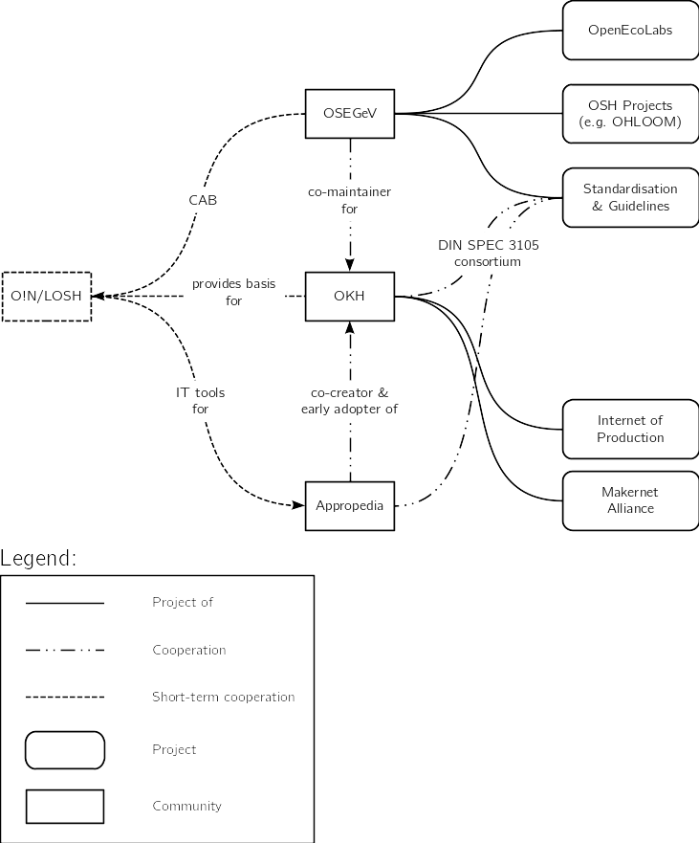Figure 11: Interactions with and between OSH communities for this deliverable
The team conducted cooperations inter alia with the organisations described above. Main points of interaction were:
- the conformity assessment body of OSEGeV;
- the OKH specification of OKH;
- auxiliary IT tools for Appropedia.
As OPEN_NEXT ends in 2022, these collaborations are short-term.
Strategic goals of these collaborations were to:
- develop the tools of WP3 against practical requirements;
- foster a reasonable quality in OSH documentation and to align LOSH towards that;
- practice design reuse and base development on work already carried out and experiences already made;
- ensure long-term maintenance and that development of LOSH is taken further.
The cooperation with OKH gave access to background information and rationales through their developers. Furthermore, this helped develop solutions compatible with OKH for a potential handover. OKH expressed interest to build upon LOSH (specifically the Krawler and OKH-LOSH) and to maintain parts of it, since these solutions take the idea of OKH further, while ensuring downward compatibility. In particular, OKH explores the LOD concept for their approach. Likewise, Appropedia, as a first step towards LOD, shifted during the development of LOSH to a semantic wiki to improve the structure of their database.
Other than defined in the grant agreement, OSEGeV already hosts the Wikibase instance, WikibaseReconcileEdit and the frontend of LOSH. Since OSEGeV assures hosting of LOSH for a minimum of three years after the end of the OPEN_NEXT project, this change removed the transfer effort from TUB to OSEGeV servers, while OSEGeV already gains experience with running the LOSH system during the project. The organisation continues with community-based quality control of OSH documentation according to DIN SPEC 3105-2. As assessed OSH modules are also listed on LOSH, they may provide a best practice reference for similar projects.

Summary and Outlook
This deliverable sets up core components for LOSH and thus provides the basis for the yet ongoing task “Data collection” (T3.4). Once populated with data (by the end of deliverable D3.4 “Populated database”, February 2022), LOSH will feature the biggest free knowledge base of audited OSH solutions from different platforms available online. Data, software and specifications have been designed and published in a way to foster exploitation, including commercial exploitation, to a maximum extent. That way the deliverable aims to contribute to the overall impact open source soft- and hardware solutions have in the European Union: A study quantified that impact to 65…95 billion Euro in 2018 across all member states with a cost-benefit ratio slightly above 1:4, while SMEs feature by far the most active group of contributors [13].
By the submission of this report, the frontend is still under heavy development and could not be deployed for usage. However, this will be finished by the deliverable of D3.4 (February 2022).
LOSH as a free-of-charge online service has been designed to support users to:
- find existing OSH solutions for design reuse or replication;
- identify relevant communities in a specific field of technology;
- scan the OSH market faster (e.g. to identify gaps and overlaps) in order to pilot new business cases.
For SMEs this is particularly useful for ideation, to find inspiration in existent solutions, to reduce development efforts by design reuse and to get connected with relevant communities. This helps to:
- find a feasible design for a specific problem, while considering practical limits visible in existent, similar solutions;
- reduce development efforts by (possibly) directly copying (parts of) existent solutions for the desired use case;
- get connected with the communities behind relevant solutions in order to collaborate on joint efforts.

Within the OPEN_NEXT project this will be validated with partnering SMEs.
Especially for actors new in the field of OSH, as e.g. many SMEs, the LOSH platform provides them with a low-threshold entry point to the scene to find and connect to relevant OSH projects – and in turn to be found by other communities. LOSH only hosts data about OSH modules available under officially endorsed free/open licenses, ensuring e.g. their commercial exploitability. This is a fundamental advantage over other online available databases of OSH solutions, such as OHO.wiki. LOSH is neither limited to a specific field of technology, as e.g. CERN’s OHWR.org, nor bound to prior certification or onboarding processes, such as the registry of OSHWA-certified OSH. As a crawler-based knowledge base it enlarges automatically, keeping maintenance at a minimum – in contrast to fully manually curated OSH registries such as from the OKH project. Due to the design of a distributed database, it ensures full data sovereignty for data providers: OSH developers and platform owners. LOSH is the only online platform providing OSH metadata as LOD, qualifying it to 5 from 5 stars of open data [14].
A basis for this is the OKH-LOSH specification and ontology. The current version 1.0.0 of the specification provides a robust approach for the pilot phase of LOSH within the OPEN_NEXT project. If broadly adopted, the specification and ontology can be a stepping stone to progressively organise OSH information as LOD. As by the progress made in the realms of machine-readable standards [15], e.g. calculation tables and certification requirements could be linked directly to corresponding parts of the open technical documentation, as well as designs, calculations, simulations and parts of OSH among each other. Such an “Internet of Open Hardware” could boost the advance of open source technologies. When developing new products, a set of requirements could directly be checked against discrete information publicly available online using scripts and potentially enabling massive reuse of already carried out work.
A similar dynamic would be applicable to automatically connect e.g. hardware components to suitable local manufacturers or open source projects to matching funding programmes.
A connection to existing open access industrial symbiosis databases would support the use of waste components for OSH-related manufacturing and thus contribute to a circular economy that reuses components before they get recycled [16].
Likewise, with a suitable extension, LOSH would also be capable of handling data from Digital Product Passports (which already have been subject to a public consultation by the European Commission [17]), enhancing long-term repairability, refurbishability and recycability of OSH products [18]. Pursuing this vision, OSEGeV is currently developing a tool that automatically integrates QR codes referencing the underlying documentation release on PCBs when using KiCAD [19]. By that, produced PCBs become physically referenced to their complete technical documentation, featuring an extensive Product Data Passport and making broken PCBs repairable or replaceable at a very low threshold and beyond manufacturer warranty. For this deliverable, the team aimed to integrate developed solutions into the open source ecosystem so that relevant communities following a similar vision (such as OSEGeV, see the previous ch. 4) will keep solutions alive and maintained for the future. Besides that, cooperations with these communities support a growing network of open source organisations shaping and maintaining a digital infrastructure for OSH in general. Such a network may hold potential cooperation partners for fab labs and SMEs and support them porting open source solutions into the market.

Glossary

Application Programming Interface
An application programming interface (API) is a connection between computers or between computer programs. It is a type of software interface, offering a service to other pieces of software [20].

Fab lab
A fab lab (fabrication laboratory) is a small-scale workshop offering (personal) digital fabrication. It is typically equipped with an array of flexible computer-controlled tools that cover several different length scales and various materials [21].

Linked Open Data
“The cross linking of Open Data via the Internet and the World Wide Web as “Linked Open Data” (LOD) offers the possibility of using data across domains or organizational borders for statistics, analysis, maps and publications. […] Linked Open Data are all stored data connected via the World Wide Web which could be made accessible in a public interest without any restrictions for usage and distribution” [22].

Open Source Hardware
“[…] hardware for which a free right of any use belongs to the general public and whose documentation is completely available and freely accessible on the Internet” [4].

OSH Module
An OSH module can be any tangible object for which relevant technical documentation has been published under a license complying with terms stated by the OSHWA definition; in most cases that will be an assembly of parts fulfilling a defined functions, whereby documentation is published on an online platform of choice (e.g. GitLab). Scope, content and limits of such OSH modules are defined by their developers. For OKH-LOSHv1 we identify an OSH module by its repository – each module is developed (and version controlled) in one specific repository [23].

SPARQL
The "Simple Protocol and RDF Query Language” is a semantic query language for databases able to retrieve and manipulate data stored in Resource Description Framework (RDF) format. As RDF, it is a specification by the W3C and a key technologies of the semantic web [24].

Licenses & Attributions
All software and related documents have been licensed under the GNU General Public License Version 3.
This report has been licensed under the Creative Commons Attribution 4.0 International license and made publicly available on GitHub.
The report, including the annexure, uses the following images under free/open licenses:
Image | Name & Source (linked) | Author | License
 | document | arjuazka | CC BY 3.0
 | platform | Adrien Coquet | CC BY 3.0
 | scientist | Gregor Cresnar | CC BY 3.0
 | transporter | Ralf Schmitzer | CC BY 3.0
 | Wikibase logo | H. Snater | GPLv3
 | database | IcoMoon | CC BY 3.0
 | process | un·delivered | CC BY 3.0
 | Binoculars | Gabriele Malaspina | CC BY 3.0
 | GitLab logo | GitLab | CC BY-NC-SA 4.0
 | GitHub logo | GitHub | NOT FREE (fair use) https://github.com/logos
 | book | Deemak Daksina | CC BY 3.0
 | robot | Jean-Philippe Cabaroc | CC BY 3.0
 | group | Arif Arif | CC BY 3.0
 | engineer | Gan Khoon Lay | CC BY 3.0
 | geek | Ayub Irawan | CC BY 3.0
 | Laptop | Mario Köstl | CC BY 3.0
 | Plug | mikicon | CC BY 3.0
 | search bar | FayraLovers | CC BY 3.0
 | Upload | Cynthia Yosephine | CC BY 3.0

References
[1] J. Bonvoisin, R. Mies, R. Stark, and R. Jochem, ‘Vielfalt und Stand der Open-Source-Hardware’, in Interdisziplinäre Perspektiven zur Zukunft der Wertschöpfung, T. Redlich, M. Moritz, and J. P. Wulfsberg, Eds. Wiesbaden: Springer Fachmedien, 2018, pp. 121–133. doi: 10.1007/978-3-658-20265-1_10.
[2] M. Moritz, T. Redlich, and J. Wulfsberg, ‘Best Practices and Pitfalls in Open Source Hardware’, in Proceedings of the International Conference on Information Technology & Systems (ICITS 2018), Cham, 2018, pp. 200–210. doi: 10.1007/978-3-319-73450-7_20.
[3] ‘OSHWA Certification Process - Hardware’. https://certification.oshwa.org/process/hardware.html (accessed Mar. 20, 2021).
[4] ‘DIN SPEC 3105-1:2020-07, Open Source Hardware_- Teil_1: Anforderungen an die technische Dokumentation; Text Englisch’, Beuth Verlag GmbH. doi: 10.31030/3173063.
[5] A. Ezoji, J. F. Boujut, and R. Pinquié, ‘Requirements for design reuse in open-source hardware: a state of the art’, Procedia CIRP, vol. 100, pp. 792–797, 2021, doi: 10.1016/j.procir.2021.05.042.
[6] A. Narduzzo and A. Rossi, ‘Modular Design and the Development of Complex Artifacts: Lessons from Free/Open Source Software’, p. 40.
[7] J. Bonvoisin, J. Molloy, M. Haeuer, and T. Wenzel, ‘Standardisation of practices in Open Source Hardware’, arXiv:2004.07143 [physics], Apr. 2020, Accessed: Aug. 18, 2020. [Online]. Available: http://arxiv.org/abs/2004.07143
[8] ‘OPEN.Effect’, Fraunhofer-Institut für Produktionsanlagen und Konstruktionstechnik. https://www.ipk.fraunhofer.de/de/referenzen/open-source-corona.html (accessed Oct. 06, 2021).
[9] L. Wei, ‘Overview on Linked Data: Concept, Technology and Implementation [J]’, Journal of academic libraries, vol. 2, pp. 5–12, 2011.
[10] ‘Open Know-How Website’. https://openknowhow.org/ (accessed Sep. 30, 2021).
[11] ‘Startseite | OSE-Germany e.V.’, Startseite | OSE-Germany e.V. https://www.ose-germany.de/ (accessed Sep. 30, 2021).
[12] ‘Appropedia:About’. https://www.appropedia.org/Appropedia:About (accessed Sep. 30, 2021).
[13] K. Blind et al., ‘The impact of Open Source Software and Hardware on technological independence, competitiveness and innovation in the EU economy’, 2021.
[14] R. Matheus, J. Vaz, and M. Maia Ribeiro, Open Government Data and the Data Usage for Improvement of Public Services in the Rio de Janeiro City, vol. 2014. 2014. doi: 10.1145/2691195.2691240.
[15] ‘Scenarios for Digitizing Standardization and Standards’, DIN/DKE. [Online]. Available: https://www.din.de/resource/blob/801106/0251eb1280a9a97e53285d42d3bf1fea/whitepaper-idis-en-data.pdf
[16] D. Jato-Espino and C. Ruiz-Puente, ‘Fostering Circular Economy Through the Analysis of Existing Open Access Industrial Symbiosis Databases’, 2020, doi: 10.3390/su12030952.
[17] ‘Sustainable products initiative’, Have your say. https://ec.europa.eu/info/law/better-regulation/have-your-say/initiatives/12567-Sustainable-products-initiative/public-consultation_en (accessed Oct. 05, 2021).
[18] T. Adisorn, L. Tholen, and T. Götz, ‘Towards a Digital Product Passport Fit for Contributing to a Circular Economy’, 2021, doi: 10.3390/EN14082289.
[19] hoijui, KiCad image/QR-Code injector. 2021. Accessed: Sep. 29, 2021. [Online]. Available: https://github.com/hoijui/kicad-image-injector
[20] M. Reddy, API Design for C++. Elsevier, 2011.
[21] N. A. Gershenfeld, Fab : the coming revolution on your desktop--from personal computers to personal fabrication. New York : Basic Books, 2005. Accessed: Oct. 26, 2021. [Online]. Available: http://archive.org/details/fabcomingrevolut00gers
[22] C. P. Geiger and J. von Lucke, ‘Open Government and (Linked) (Open) (Government) (Data)’, JeDEM - eJournal of eDemocracy and Open Government, vol. 4, no. 2, Art. no. 2, Dec. 2012, doi: 10.29379/jedem.v4i2.143.
[23] Moedn et al., OPEN-NEXT/OKH-LOSH: v1.0.0. Zenodo, 2021. doi: 10.5281/ZENODO.5608513.
[24] T. Segaran, C. Evans, and J. Taylor, Programming the Semantic Web: Build Flexible Applications with Graph Data. O’Reilly Media, Inc., 2009.

see Glossary (ch. 6.4) for a definition of the term
The name is borrowed from the Open KnowHow Specification (OKH), since OKH-LOSH is based on that specification and shall contribute back to it.
see Glossary (ch. 6.3) for a definition of the term
Specifically, this was part of the former deliverable D3.1 “Assessing the needs”.
see Glossary (ch. 6.2) for a definition of the term
specifically from T2.3 “Facilitating Documentation for design reuse”
carried out in the former deliverable D3.1 “Assessing the needs”
see Glossary (ch. 6.1) for a definition of the term
See ch. xxx in the annexure for details.
For instance, instead of maintaining an own list of free/open licenses, the ontology shall refer to the SPDX knowledge base of free/open licenses (human readable list, ontology).
D3.4 “Data collection”, scheduled for February 2022
The crawler is been developed by Konek.to (subcontracted) which, in consultation with the project team, chose to name it “Krawler”.
The frontend will be accessible under this URL once deployed (scheduled for D3.4).
available under a free/open license here: https://gitlab.opensourceecology.de/verein/projekte/losh-rdf
Full installation instructions will be available once development is finished.
Installation instructions are available per module 1) in its git repository and 2) in the annexure of the corresponding deliverable.
Depublicated batch upload is enabled by WikibaseReconcileEdit; see ch. 2.4.1.4 for details.
https://gitlab.opensourceecology.de/verein/projekte/losh-rdf
A letter of intent has been signed already prior the submission of the proposal of the OPEN_NEXT project.
Note that this only applies or manifest files; the OSH project itself can be hosted on any online platform.
However, for this corresponding access rights must be requested first from OSEGeV administrators.
https://wikifactory.com/@boettger/powerplanter
https://losh.ose-germany.de/index.php?title=Item:Q1761
although it is recommended to host both, the whole technical documentation and the manifest file in the same place
https://gitlab.com/OSEGermany/ohloom
https://github.com/OPEN-NEXT/OKH-LOSH/blob/master/sample_data/okh-OHLOOM.toml
https://losh.ose-germany.de/index.php?title=Item:Q438
scheduled for D3.4 (Februrary 2022)
WikibaseReconcileEdit help abstract away Wikibase-specific internal identifiers (see design notes of the RDF2WB-Converter in ch.xxx of the annexure for details).
which of course may be different for e.g. platform owners
As an example, the Chinese company seeed published the Open Part Library, a large registry of electronic components popular in OSH designs. Components on this list are available at low costs and delivery times and with KiCAD libraries – in consequence the list is emerging to a list of “standard components” for OSH PCBs. Similar business cases would be possible for other sectors, while LOSH helps identifying potential niches.
A post in the seeedstudio blog from 2019 lists 45 OSH platforms, not including Wikifactory, Appropedia, GitHub/GitLab, Thingiverse, Wikifab or Wevolver.
This is a critical point even on platforms the Krawler sources data from: An early test crawl of the Wikibase platform has shown that only 11,7 % of hardware projects would be freely (including commercially) exploitable under a free/open license; see the details in ch. xxx of the annexure.
However, LOSH can naturally not control and fix faulty or missing data.
once deployed it will be accessible under losh.opennext.eu
accessible under losh.ose-germany.de/qs
accessible under https://gitlab.opensourceecology.de/verein/projekte/losh-rdf/
see Glossary (ch. 6.6) for a definition of the term
E.g. the Open Source Hardware Weather Report wouldn’t need to rely on OSHWA data only and public statements as regarding OSH in the scientific sector (Wilson Center) could rely on a larger and easer accessible database, reducing the effort of such publications.
e.g. Apache Jena
Combined with analyses from the dashboard (D2.2 “Creating a design process facilitation dashboard”), data could be used to e.g. create a track of all developments carried out from a defined GitHub account. Together with tags from the skill ontology (as introduced by D3.2 “Developing the platform features”) this could feature a digital, machine-readable CV.
E.g. the linking of latest findings in therapy methods for the Coronavirus disease 2019 with OSH ventilator designs could help adjust development plans of such hardware.
available under https://losh.ose-germany.de/qs/
such as the LOSH-Frontend, which is getting information precisely via the described way
To view the results, just click the highlighted link.
https://gitlab.opensourceecology.de/verein/projekte/losh-rdf
Users should use version-specific references so that those linkings are stable. However, it is expected that users skilled in the field of RDF are aware of this aspect.
see Glossary for a working definition of the term
meaning, that when the specification is followed and metadata is published on one of those platforms, it will be automatically found by the Krawler and uploaded to LOSH
As within the scope of data collection, this will be finished with the deliverable of D3.4 (February 2022).
although technical options towards this have been explored
As linked in the README of the repository, rendered graphs are available here. When the ontology contains invalid syntax, the rendering returns an error.
by the deliverable of D3.4 (February 2022)
an online assistant and graphical interface for the creation of manifest files
whereby strong copyleft licensing terms apply
as the team also did in the ontology itself, e.g. by referencing IDs from the SPDX ontology directly
As described in the official git documentation: “Git has the ability to tag specific points in a repository’s history as being important”. Once tagged, these points, equaling a specific version of the code, can be easily referenced.
GitHub provides rendered HTML pages per default to enhance user experience; however uncompressed (raw) files are far easier to handle for algorithms.
GitLab’s CI/CD tool allows the automatic execution of commands and tools after each change made in the repository.
Find auxiliary information about the Mediawiki API here: https://www.mediawiki.org/w/api.php .
An account with sufficient rights can otherwise requested from OSEG administrators at verein@ose-germany.de .
The frontend will be accessible under this URL once deployed (scheduled for D3.4, February 2022).
as by September 29th 2021
Casually speaking, OpenEcoLabs can be seen as fab labs or Makerspaces with clear focus on open source products respecting the ecological impact of the same. For a profound understanding, see the OpenEcoLab Manifesto.
For the previous deliverable D3.2 („Platform demonstrator“), the team collaborated with OSEGeV to provide a very short version (tl;dr) of OSEGeV’s guideline for legal issues.
The organisation now contributues to the CEN/CENELEC project Open Source Solutions in order to introduce open source principles to standardisation practices in the EU.
as from Appropedia as a platform owner, OSH developers and OpenEcoLabs
since that is what the user base (incl. fab labs and SMEs) would benefit most from
A semantic wiki is a wiki with embedded machine-readable (or machine-intuitable) data so that the relationship between articles and information can be defined. As a result, the wiki can be queried or exported like a database through semantic queries.
The grant agreement states FHG hosting Wikibase on servers provided by TUB.
and with it possible errors after transferation impeding the provision of the service
As described in ch.xxx, the Krawler checks results for free/open licensing terms and minimum documentation quality criteria before uploading them to the Wikibase instance.
As an example, the Chinese company seeed published the Open Part Library, a large registry of electronic components popular in OSH designs. Components on this list are available at low costs and delivery times and with KiCAD libraries – in consequence the list is emerging to a list of “standard components” for OSH PCBs. Similar business cases would be possible for other sectors, while LOSH helps identifying potential niches.
Meaning that they have been approved by either the Free Software Foundation or the Open Source Initiative and are hence included in the SPDX license list.
The platform includes many YouTube videos of DIY projects and hardware licensed under non-commercial terms.
Projects need to submit their manifest file in this spreadsheet in order to get listed: https://github.com/OpenKnowHow/okh-search/blob/master/projects_okhs.csv .
such as applying welding parameters and then again linked required welder examination for manufacturing
Note that OSH designs can be easily altered towards specifications, properties and interfaces those waste components may have (e.g. different pin assignment in the case of electronics)
a widely used FOSS for the development of PCB designs
https://www.gnu.org/licenses/gpl-3.0.html
https://creativecommons.org/licenses/by/4.0/legalcode
https://github.com/OPEN-NEXT/D3.3-Report

